NVFSC Board Meeting MInutes
August 28, 2023; 8:00 PM

- Call to order: 8:03PM

- Attendance: Priya Baboo, Terry Branstetter, Lori Coup, Beth Kalbach, John Kalbach, Tina Konrath, Donna Korzick, Min Lee, Gloria Leous, Jon Malcos, Anne Martin, Jess McCormick, Gary Mitchell, Wendy Pearson

- Welcome Back bags—Lori coordinated
  - Much appreciated

- Master in Free Skate from PSA—Gloria
  - Congratulations, for further celebration

- Approval of minutes from
  - June 26, 2023 meeting: motion, Gloria, Second Priya, ALL APPROVED
  - May 8, 2023—fold into the September meeting

- Treasurers Report – Wendy Pearson
- Monthly Update
  - ~$20K in bank
  - July/August report: Donna, Tina, ALL APPROVED
- Year End Update
  - FY ended 6/30/23. Finishing in the Red ~$3000 (did not include Centre Gives)
  - Two-year comparison was distributed to Board. (Holiday Show ice cost was not broken out for 2021)
  - Concessions up, Club Ice also up
  - Annual Report: Tina, Gary, ALL APPROVED
- Club Ice impact in September—what level of subsidy?
  - Collegiate participation makes a big impact
- AYMS
  - $4K last year, $2K this year
  - Selection committee asks about balance (~700 remains)

- Membership Report – Donna
  - 67 Members—should match USFS
    - 11 new members
    - How often do we submit batch memberships?—Monthly, in the middle ($3 fee for rush processing to cover USFS charges)
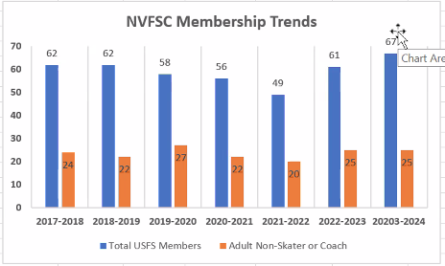
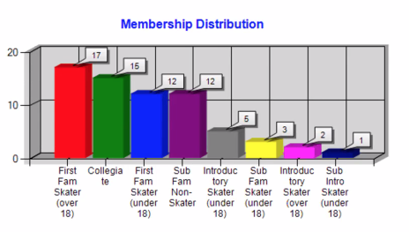
  - EntryEeze Discussion – Donna/John
    - Two recent changes:
      - under-18 require guardian-activated
      - If incorrect membership is selected, refund is enabled
  - Aspire Program Update – Donna/Tina/John
    - See meeting notes 8/25/23
    - Attending: Rachel Landers, Deb Campbell, Tina Konrath, Gordon Harris (USFS), Heather Hulle (USFS)
    - Manual process
    - Impact to our Club:
      - Aspire members would count towards out club which could lead to an extra vote
      - Could promote program growth, but ice time can be a limited factor to growth
      - Testing requires progression past Aspire
      - Partnership between Rink and Club
    - Continue to investigate other Aspire Programs
  - Membership Types – Donna/John/Anne/Tina
    - See Membership Option Comparison
    - “Friend of the Club” option---for future discussion
    - Discussion points
      - Beginners—no issues
      - Full—no issues
      - How to incorporate Aspire into Club Ice? Hours, benefits, costs
    - Support Aspire Membership: Donna, Anne, ALL APPROVE
    - Aspire Membership ($40 to club) to access club ice at < 5 hours: Donna, Wendy, 4 PRO, 5 OPPOSED
    - Junior Associate Member for $20 (option from comparison table) club ice hours to be determined: Anne, 10 PRO, 1 OPPOSED
    - Junior Associate Members (from comparison table--access 2 hours Sunday, 1.5 Tue, no access on Thursday, plus off ice activities): Anne, Tina, 10 PRO, 3 OPPOSED
    - Follow-on action to implement this new membership type

- Club Ice – John/Gary/Anne/Tina
  - Expecting Fall schedule this week
    - Provide feedback to skip dates, anticipate virtual vote
  - Acuity System – John/Anne/Tina
    - Operational—caps at 20 skaters, must pre-pay, no (yet-implemented) wait list
    - Supports
      - Subscription – assumes skater will show and count against 20
      - Pass – now called Package (should have scheduling priority over Walk-on)
      - Walk-on – now called Pay as you go
  - Pricing for all types of Club Ice Access: Anne, Terry, 11 PRO, 1 OPPOSE
    - Subscription--$11/hour Full/Asso Member
    - Pass--$13/hours Full/Asso/Junior
    - Walk--$16/hour
    - Could have a stand-by option—will need some work
  - Who has access to Subscription/Package/Pay as you go (see above)

- Volunteer Requirements
  - Sign-up for monitoring--link

- Lightning Round Topics (5 minutes each)—Tabled for next time
  - Clothes Order Update - Lori
  - Virtual Test Recording Policy review and Feedback – Tina/John
    - No DISCUSSION ON Costs!
  - Club Ice Monitor – John/Tina
  - SkateSafe Update – Beth
  - Spikes Game – John/Lori
  - Used Skate Sale

- Date of next meeting—anticipate mid-September

- Adjournment : Wendy, Gloria, ALL APPROVE 10:13PM

