NVFSC Board Meeting Minutes
September 25, 2023

- Call to order 8:01PM

- Attendance: Priya Baboo, Terry Branstetter, Lori Coup, Beth Kalbach, John Kalbach, Tina Konrath, Donna Korzick, Min Lee, Gloria Leous, Jon Malcos, Anne Martin, Jess McCormick, Gary Mitchell, Wendy Pearson

- Approval of minutes
  - August 28, 2023 meeting. Motion to approve Gloria, 2nd Gary, All Approve
  - May 8, 2023 meeting. Motion to approve: Donna, 2nd Gloria, All Approve

- Treasurers Report – Wendy Pearson
- Monthly Update: Motion to approve, Jess, 2nd Min, All Approve
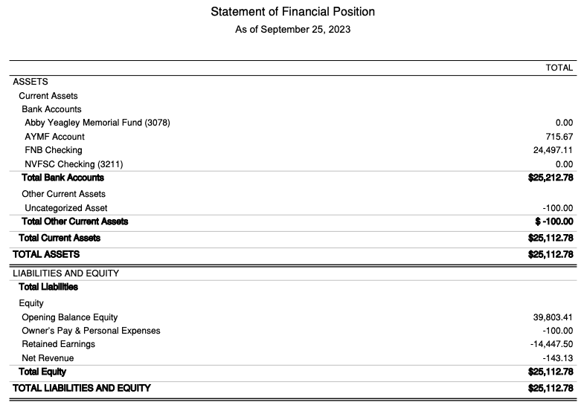
b) Ability to itemize monthly Acuity and Entreez, directly or via Stripe? John to research Acuity and Entreez; Tina to research Stripe.

- Membership Report – Donna
  - Membership Update: Members increased from 67 to 78 since August 2023 board meeting.
    - Two new collegiate, 3 new ‘intro/regular’ members, 8 junior associates (2 switched to junior which explains why total didn’t increase by 13)
    - Warning about Entryeeze graphics: cannot plot all categories in bar graph form
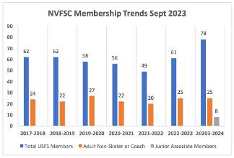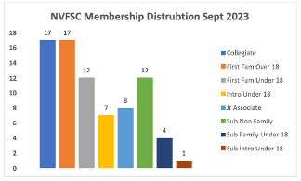
  - Outstanding issues: USFS accounting of Junior/ASPIRE members (10% of total NVFSC members)? John will create an ASPIRE field.
  - New Membership Chair
    - Donna stepping down through September
    - Motion to nominate Priya as replacement. Tina, 2nd Jess, All approve.
    - Donna and Priya to coordinate turnover. John to make changes in USFS, target 10/1/23.

- Club Ice – John/Gary/Anne/Tina
  - Acuity System – John/Anne/Tina
    - October dates are loaded, Subscriptions are added for October
    - Still working through implementation
  - Fall Club Ice Booking Report
  - Ice usage Report September
    - 3 half-hours sessions going over 20 skaters–see report
    - Procedures and incentives for canceling unused subscription ice?
      - Current: cancelation deadline is one hour prior to session
      - Need to determine ability for Acuity to support monitoring procedures
  - Monitor Signup for October
  - Future Virtual Video Test Recording Dates
    - 9/27 @ 7:30PM (no freestyle prior)
    - October–10/27 Oct 30, 2023 7:30 PM
    - November–actual date may change
    - 12/19 @ 6:45PM

- Holiday Show
  - Dec 10 – Show 1:00 – 3:30 (we have the ice starting at 12:30 for warm up)
  - Dec 7 – Dress rehearsal 6:30 PM – 9:30 PM (no club ice)
  - Sub-Committee
    - Director and Committee Members
      - Beth and Jess–Co-directors, local and remote
      - Donna & Lori–continue and build upon prior year efforts
        - Refresh branding by early-October to begin advertising
        - Engage high school skaters–Tina
    - Fundraising
      - 50/50 requires pre-coordination for Game of Chance License–Tina to provide prior-year form to John

- Used Skate Sale
  - Potential Dates Nov 8 and 12
    - Need to coordinate time and date with Deb–Min
    - Both dates align with Aspire
  - Volunteers
    - Min is willing to coordinate
    - Ann Birchard will to assist
  - Aspire Access (comment passed by Rachel)--no special access

- Joint Aspire Programming
  - To what extent do we consider them as club members?
    - Waiting for Aspire roster
    - Aspire (like Learn to Skate), can skate on our ice–at level, pay as you go, with waiver
  - Off ice work – Limited Freestyles in October
    - Split programming with rink to add Aspire?
    - Engage coaches on programming interest–Gloria
  - Education Sessions
    - Review Testing Oct 25
    - Share previous videos or invite to watch Oct 27

- Lightning Round Topics (5 minutes each)
  - Calendar - Tina
    - Link forthcoming–(posted)
  - Clothes Order Update – Lori
    - Sweatshirt interest, reopening
    - Communications to new members
  - Club Ice Monitor – John/Tina
  - SkateSafe Update – Beth (Nothing significant to report)
  - Homecoming Parade – September 28
    - Pizza donation–Min
    - Float prep today
    - Banner–Tina
  - Fund Raising - Gary
    - Less games this year–see email for schedule and signup
    - 10/20, 10/21 first concessions opportunity at Top Shelf

- New items not covered in this agenda
  - Can we get a master ice schedule to be more transparent about ice usage? Haven’t had success in the past.

- Date of next meeting–schedule next meeting to coincide with Holiday Show Committee prep

- Adjournment: Jess, 2nd Tina, All Approve (9:32PM)

