NVFSC Board Meeting Minutes
November 13, 2023; 8:00 PM

- Call to order: 8:03PM

- Attendance: Priya Baboo, Terry Branstetter, Lori Coup, Beth Kalbach, John Kalbach, Tina Konrath, Donna Korzick, Min Lee, Gloria Leous, Jon Malcos, Anne Martin, Jess McCormick, Gary Mitchell, Wendy Pearson

- Approval of minutes from September 25, 2023 meeting—Motion Tina, Second Gary, Approved

- Approval of minutes from October 30, 2023 meeting—Motion Donna, Second Gloria, Approved

- Treasurers Report – Wendy Pearson
- Monthly Update - None
- Accounting of payment systems – John
  - Reporting / Data
    - ENTREEZE Report—Treasure Calendar (adequate breakdown)
    - No Acuity report available
    - Stripe Report – No easy way to differentiate between Acuity and ENTREEZ
  - Acuity data might be extractible by removing ENTREEZE data from Stripe Report
  - Credits should account for fees—item for education during next membership cycle—Motion Anne, Second Terry, Approved
- Membership Report – Priya/Donna
  - 82 total
  - October report
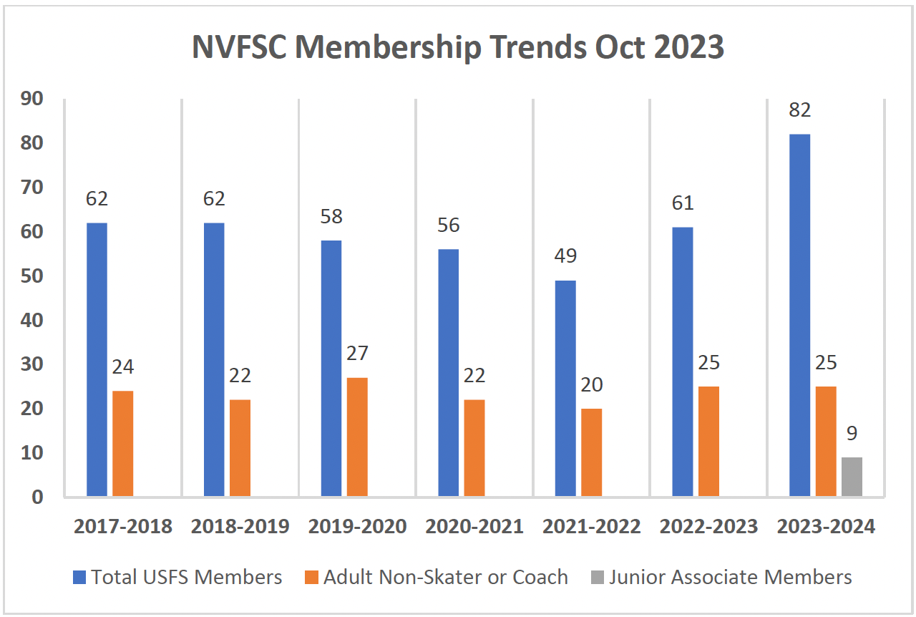
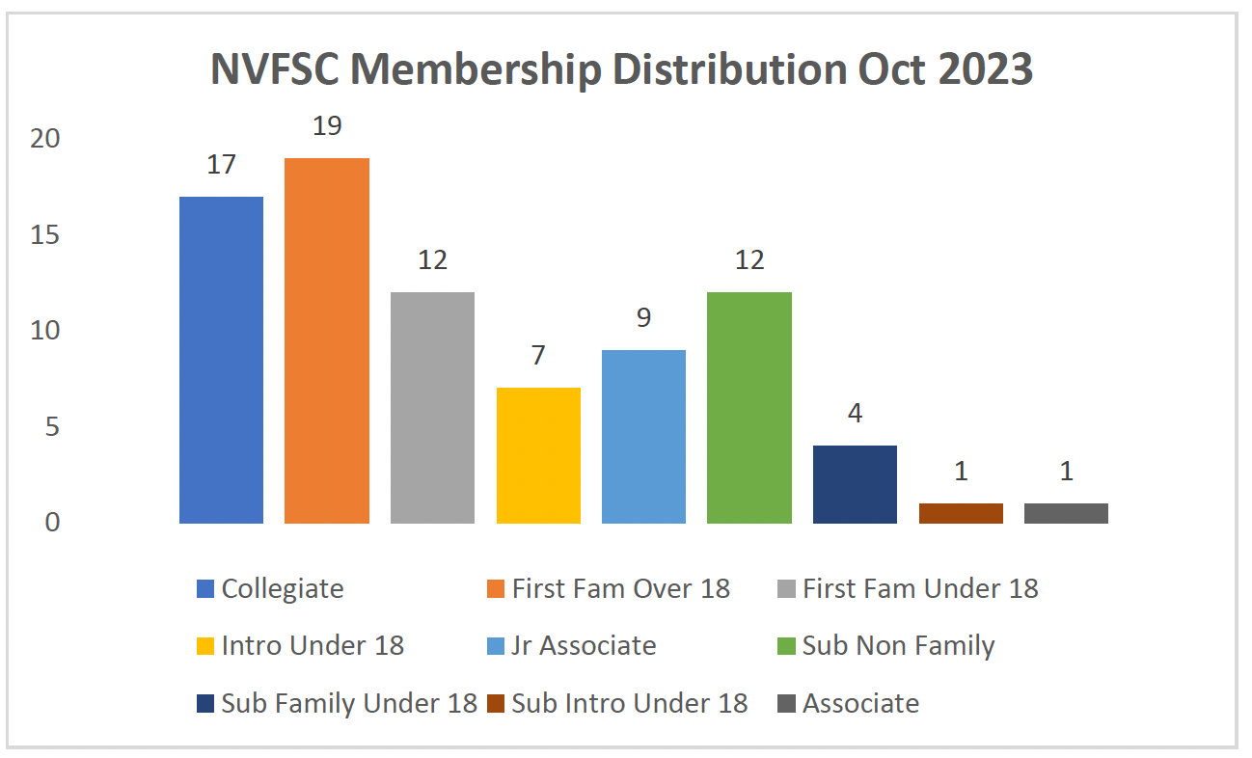

- High School Team Reimbursement
  - $35 paid by Tina: Motion Gloria, Second Donna, Approve

- Holiday Show Dec 10
  - Applications: 20 solos, 7 groups. Closes 11/15
  - Group Number: practices scheduled
  - Advertising: Donna, Lori working. Poster/signs for display case (Donna to John for Rink approval)
  - Volunteers
  - Gold Medals: need to be procured (Jess, John)
  - Fundraising - 50/50: Have license, have tickets
  - Honor Seniors (Hight School and Collegiate): being coordinated (Beth)
  - Script: Beth content, Gloria draft, John prior examples
  - Printed Program
  - Printed Tickets: one color (Donna) In-person ticket sales 12/3, 12/5, and 12/7
  - 85 already sold online
  - Food drive: Julia to coordinate, Donna to store until Ugly Sweater event (John: will the rink allow a box to stay out/partner for food donations?)
  - Advertise during hockey games? Senior skate during hockey intermission? (John)

- Club Ice – John/Gary/Anne/Tina
  - November 16
    - Schedule
      - Show Practice: 5:30—6:15
      - Club 1: 6:15—7:45
      - Club 2: 8:00—8:30
      - Test (5): 8:30—9:15
    - Ice Monitors/Locker Rooms –Give back (limited approved people to monitor)
  - Ice usage Report September/October – John/Anne
    - Skaters paid for 75% of the ice bill (only fundraising for 25%)
    - Incentives for cancelling unused subscriptions—item for future discussion
  - Spring Break Ice Times: Keep 1 hr Sunday 3/3, 1 hr Tuesday 3/5, remove Thursday 3/7, and 2.5 hrs Sunday 3/10
  - Ice Monitor – John/Tina/Donna
    - Board is responsible, but monitors need not be board members
    - Are two monitors required?
    - Monitor training requirements?
    - Options Tabled for future discussion

- Used Skate Sale Update—Min
  - Good quality dresses and skates
  - $690 in sales

- Lightning Round Topics (5 minutes each)
  - Aspire Programming Update – John/Tina: Spoke at Parent Meeting
  - Clothes Order Update – Lori: Orders going in 11/14, next order in the Spring
  - SkateSafe Update – Beth: None
  - Fund Raising – Gary: 6 hockey games, earned ~$2500 to be divided, on par with last year, 4 more games

- Volunteer commitment ideas for future years? Item for further discussion.

- Date of next meeting: 12/18/23 @ 8PM

- Adjournment @ 9:48PM: Motion Tina, Second Gary, Approved

