NVFSC Board Meeting Minutes
December 18, 2023; 8:00 PM

- Call to order: 8:01PM

- Attendance: Priya Baboo, Terry Branstetter, Lori Coup, Beth Kalbach, John Kalbach, Tina Konrath, Donna Korzick, Min Lee, Gloria Leous, Jon Malcos, Anne Martin, Jess McCormick, Gary Mitchell, Wendy Pearson

- Approval of minutes from November 13, 2023 meeting. No edits. Motion to approve—Gary, 2nd—Tina, ALL Approve

- Treasurers Report – Wendy Pearson
- Monthly Update: There is approx. $20K in the bank. This amount does NOT include: (1) used skate sale proceeds; (2) clothing order income and (3) cash ticket sales and raffle. It does include club ice purchases through November.
- Used Skate Sale checks mailed today
- Request fall breakout of ice cost and recovery for next meeting to inform future planning
- Motion to approve—Tina, 2nd—Gloria, ALL Approve

- Membership Report – Priya
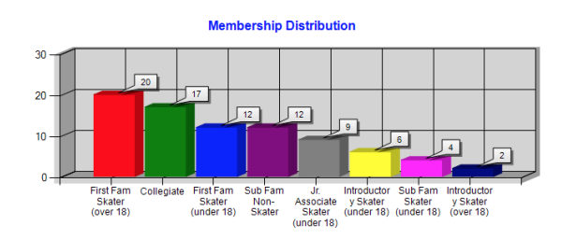
- Holiday Show Dec 10 – Recap
  - Feedback: Event
    - Nice addition of Food Drive (exceeded 300 pounds)
    - Good attendance—continue to build
    - Paid sponsor (Anderson) worked well, will continue to support
    - Skaters seemed to enjoy event—no drama
    - Group number first makes for a good show kick-off and skater warm-up
  - Feedback: Planning
    - Planning/communication was bifurcated—creative and logistics—improve coordinated committee
    - Announcement came late which may have limited participants
    - Committee and planning should get activated in October
    - Skaters did not receive confirmation of program acceptance
    - Allocate show time purposefully—groups, seniors, college, little ones
    - Refreshed graphics which will help in the future (signs can be updated early)
    - Aviva--possible committee member supporting copy writing

- Club Ice – John/Anne/Tina
  - Spring Ice Times Anne/Tina/John
    - Proposing similar approach to Fall
    - April pricing can be adjusted (as needed) if Spring Break (3/3, 3/5) changes schedule (need to give back ice time more than a week prior)…note possible ice monitoring availability of tracking spreadsheet
    - First ice is 1/2/24
  - Ice Monitor – John/Tina/Donna
    - Discussion on coverage options
      - Sub-committee: Donna, John, Gloria, Priya
      - Monitoring (Spring) and Volunteering (next year)
    - Do we need two?
      - Yes—min of two
      - Min one Board member and/or SafeSport
      - One Board rep is important for consistency, reporting, and Aquity
    - Who can monitor?
      - Parent as a second?
      - SafeSport requirement?
      - Volunteer requirement model—refine for next year?
      - Request monitors for Spring

- Spring Clinic - Donna
  - Paul Wiley being engaged
  - Need to determine ice requirements to check availability
  - Group and level-specific sessions (may help ice scheduling) – Low, High, All
  - Open to outside skaters (at different rates)

- Gold Medals – John
  - Historical precedence to purchase medals ($150 each)
    - Would AY be willing to support club with these purchases? (John, Jess)
    - Should it be from a club? (Donna)
    - A Deena Yeagley fund/scholarship is being organized and might be repurposed (Gloria)

- Lightning Round Topics (5 minutes each)
  - Aspire Programming Update – John/Tina
    - Meeting today with Rachael—very positive
    - Trying to coordinate program schedules (on and off ice, FS versus Club)
    - Spurred discussion about consistent ice (Rachael and Brian)
  - Dr. Lally Clinic – Tina
    - Joint Aspire/Rink/Club
    - Investigating Monday evenings 1/22, 2/12
    - $200/clinic
    - Rachael looking into free space
  - Clothes Order Update – Lori
    - Announced, bringing to Tue Club
    - Coach jacket embroidery
      - Small logo and name <$50
      - Club could pay for set-up fees ($65 for small logo)
      - Lori to research further and plan for email vote to spend
  - SkateSafe Update – Beth (Skipped)
  - Fund Raising – Gary
    - 10 hockey games--~$4700 (split with collegiate) Club share at least $3500 (tips and pretzels not yet included in these figures)
    - 9 games scheduled for spring—sign-up email coming after holiday
  - Website John/Lori
    - Vendor identified…recommendations coming early in the new year

- Excel Series
  - Calendar released
  - Registration opened
  - Changes from previous years…another meeting (maybe Zoom) and/or Newsletter
  - High School Team planning—Gloria/Tina

- Date of next meeting—to be polled

- Adjournment 9:25PM: Motion—Gary, 2nd—Donna, ALL Approve

