NVFSC Board Meeting Minutes
January 22, 2023; 8:30 PM

- Call to order: 8:31PM

- Attendance: Priya Baboo, Terry Branstetter, Lori Coup, Beth Kalbach, John Kalbach, Tina Konrath, Donna Korzick, Min Lee, Gloria Leous, Jon Malcos, Anne Martin, Jess McCormick, Gary Mitchell, Wendy Pearson

- Approval of minutes from December 18, 2023 meeting. Motion Gary, Second Priya, All approve.

- Treasurers Report – Wendy Pearson
- $21,000 in the bank
- Down approx $2000 for the fiscal year
- Fall ice subsidize by 20%
  - (how does club ice spending compare across past two falls?)
  - Fall 22 $14,614, $6641 subscription–club covered ~$8000
  - Fall 23 $23,355, $18+ received–club covered ~$5000
- Holiday show profit was ~ $2170 (assuming there are no other expenses)--higher than recent years
  - Some coaching fees may yet need to be paid
- Fall concessions totalled ~ $7061; we earned $5313 and the collegiate team will receive $1748.
  - Motion to make payment to collegiate team–Gary, Second Anne, All approve.
- Test Sessions (some) remain to be invoiced. Tina working
  - Break out test session from ice payment and fees. Wendy working
- Motion to approve Treasurers Report–Donna, Second Gary, All approve.

- Membership Report – Priya
  - Total member count: 83; same as December 2023. (USFS shows 84. Priya to check.)
  - Challenge: not receiving approvals for competitions. We need to make sure this is corrected so skaters will not have any problems at competitions. Should be resolved by correcting email address.
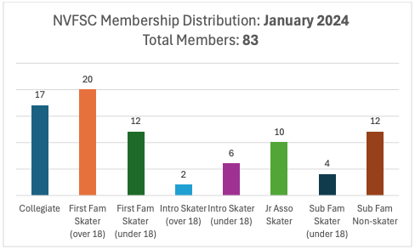

- Dr. Lally Clinic – Tina, John
  - January 29, February 12, March 18
  - Costs
    - NVFSC $35 for all three or $15 for each
    - Non-NVFSC $45 for all three or $20 each
  - Coaches and Board Members are welcome to attend
  - Total Club cost for all sessions = $600

- June 2 Clinic – Donna, John
  - Paul Wylie
  - 10:00-5:00 with an hour break
  - Club Ice moved to June 1 5-7 PM, potential private lessons with Paul
  - Coaches Clinic 8:30-9:30 June 2 on ice
  - Estimated cost–$3000 clinic time, $1000 travel, $1500 ice, $500 dance, $500 lunch
  - Planning estimates: Charge $200-250, target 20-25 participants
  - Club is prepared to subsidize up to $2000
  - Motion to approve clinic–Donna, second Jon, All approved.
  - Ice Plan
    - Saturday 5-7PM for private lessons during club ice
    - Sunday 8:30-9:30 for coaches clinic
    - Sunday clinic – need to confirm what ice we need to support (to be finalized by 1/25/24) Motion to up to six hours of ice time–Anne, Second Tina, All approve.

- Used Skate Sale
  - Learn to Skate competition slated for 4/6/24
  - Will include a senior showcase
  - Investigate vendors–Tina
  - Week of 3/18/24–used skate sale
  - Min to coordinate

- Web Site Proposal - John, Lori
  - See planning document
  - KnownHost $72 first year, $145 additional years
  - Motion to proceed–Lori, Second Priya, All approve.

- Club Ice – John/Anne/Tina
  - Spring Ice Times (May & June) Anne/Tina/John
    - Requested May be like April, June at reduced time–with Brian
  - Ice Monitor Subcommittee – John /Donna/Priya/Gloria
    - Board member for Acuity, Parent for ice monitoring
    - Handbook to record duties–targeting early Fed
    - Goal to begin soft-launch by mid-Feb
    - Proceeding–Donna / John to coordinate / communicate

- Lightning Round Topics (5 minutes each)
  - Aspire Programming Update – John/Tina
  - Clothes Order Update – Lori
    - Orders in support of used skate sale
    - Jackets for HS team?
  - SkateSafe Update – Beth
  - Fund Raising – Gary
    - Ongoing hockey concessions this season
    - May be wrestling concession opportunities
    - University may to begin contracting concessions…impact uncertain
    - Centre Gives dates: May 8th & 9th
  - Picnic Date: Tentatively 6/9/24

- Adjournment: Motion to adjourn–Donna, Second Lori, All approved. 10:24PM

