NVFSC Board Meeting Minutes
February 26, 2024; 7:30 PM

- Call to order at 7:34PM

- Attendance: Priya Baboo, Terry Branstetter, Lori Coup, Beth Kalbach, John Kalbach, Tina Konrath, Donna Korzick, Min Lee, Gloria Leous, Jon Malcos, Anne Martin, Jess McCormick, Gary Mitchell, Wendy Pearson

- Approval of Minutes from January 22, 2024 meeting. Motion to approve Donna, Second Gary, ALL APPROVE.

- Treasurers Report – Wendy Pearson
  - $30,000 in bank, have not yet paid Jan Club ice
  - Detailed report to distribute later this week

- Membership Report – Priya
  - No changes from last month
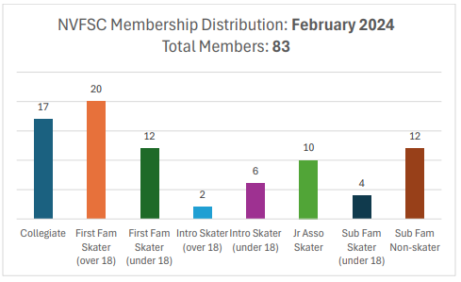

- Nate Evancho – John
  - Former club member and national competitor
  - Passed away 2/11/24
  - Sharing information

- Sanctions - John
  - General Board Information
    - Ellen and Anja asked (last minute) to skate during women's hockey game
    - Multiple sanction types, can be requested by specified roles
    - The Learn to Skate sanction prohibits streaming
    - Home club responsibility to ensure events home or otherwise are sanctioned
  - Location of previous sanctions
    - Google drive space for club and rink
  - Email address to request
    - Beth Eckard—Sanction Chair (also to Pres and VP)

- Dr. Lally Clinic Update – Tina, John
  - Lower turnout than expected
  - Slides and planning documents on Google drive
  - Next/final session (post competition debrief) March 18
  - Allow coaches at the last Clinic

- Rachel Meeting Update – John/Tina
  - Awaiting confirmation on party room for Paul Wiley
  - Aspire Education--upcoming
  - Abby Yeagley/LTS/Senior Showcase—see Newsletter
    - Poster making / goody bags for skaters—TBD
    - Can club members have a vendor table?

- June 2 Wylie Clinic Update – Donna, John, Tina
  - Secured Ice Time for Saturday and Sunday
  - Secured Paul Wylie—need to complete contract
  - Off Ice Update (possible dance counter programming) -- Tina
  - EntryEeze or Acuity for registration
  - Need to lock down pricing (member and non-member)—working offline
  - Move forward with save the date this week

- Testing – Jess, Tina, John, Wendy
  - Status of payment/billing
    - Tina compiled master test worksheet / record with payments and results
    - Including pricing reminders and policy in newsletters
  - Potential In person test session—may be moot since judges are volunteers (it seems that there will be judges onsite, but we aren't going to try to tack on the test session)
  - Invoices sent for previous Test Session

- Monitor Committee Update – John/Donna/Priya/Gloria
  - Piloting with parents (3 groups of 3)—see scheduling worksheet
  - Book is nearing final draft

- Used Skate Sale Update – March 17 and 20 (5-7:30) – Min
  - Rachel help promote
  - Collection 3/19/24, during club ice

- Web Site Update - John, Lori
  - Organizing content in preparation for site purchase

- Social Media and minors – John, Lori
  - Want to ensure we’re working within correct rules / guidelines
  - Instagram—could add Lindsey and Kendall, need to establish some written parameters
    - Channel content via Lindsay to Lori as a first step

- Centre Gives – Tina
  - May 8 and 9

- Club Ice – John/Anne/Tina
  - Spring Ice Times Anne/Tina/John
  - Apr/May/Jun returned, mostly as requested (missing test sessions)

- Lightning Round Topics (5 minutes each)
  - SkateSafe Update – Beth (nothing significant to report)
  - Fund Raising – Gary
    - Hockey concessions have concluded
    - Future events, uncertain
    - $7500 estimated earnings for the winter, to be split with collegiates
  - Picnic Date – not discussed

- Adjournment 8:54PM Motion to adjourn Donna, second Gloria, ALL APPROVE

