NVFSC Board Meeting Minutes
May 28, 2024; 8:00 PM

- Call to order: 8:03PM

- Attendance: Priya Baboo, Terry Branstetter, Lori Coup, Beth Kalbach, John Kalbach, Tina Konrath, Donna Korzick, Min Lee, Gloria Leous, Jon Malcos, Anne Martin, Jess McCormick, Gary Mitchell, Wendy Pearson, Natalie Branstetter

- Approval of minutes from March 25, 2024 meeting: motion to approve, Donna,2nd Tina, ALL APPROVE

- Junior Board Update – Natalie Branstetter
  - Students are interested
  - Getting organized over summer—leadership, service, and spirit
  - Scheduling first meeting
  - Plan to update (briefly) to June meeting with deliverable in August
  - Encourage Handbook development with Bylaws to help structure (share NVFSC Bylaws)

- Treasurers Report – Wendy Pearson
  - Report – Wendy
    - FY: net revenue ~$18K
    - $43K in bank
    - Owe May club ice
    - Report shared via email
    - Motion to approve: Gary, 2nd Gloria, ALL APPROVE
  - Fund Raising – Gary
    - Luke Combs concert at Beaver Stadium: $5000 ($4K+ to Club)
    - Fundraising metrics
      - Beer earning rate: 7.5%
      - Pegula tips typical: ~18%
      - Annual fundraising this year $23K ($19K to club)

- Membership Report – Priya
  - Report
    - No change (no written submission)
    - 83 members (known discrepancy between USFS and EntryEeze)
  - Jr. Membership – Anne/Tina/Priya/John
    - Junior Associate Member
    - Junior Club Ice did not go well this year because there was no way to enforce the registration in Acuity
    - Recommendation
      - Stop Jr Club Ice
      - Membership guideline: If Pre-preliminary Test is passed…renew as Introductory Member and continue Aspire Programming
      - Coordinate decision/choices with Pegula
      - Include updated membership FAQ notes in EntryEeze (and possibly notes linked to individual accounts/records…highly desirable)
      - Support mid-year moving from Aspire to Full in order to support Preliminary Moves testing, as required.
  - Cost increase per USFS
    - Spreadsheet distributed via email
  - Non-skating Member option—will add to membership type list ($40…USFS fee, not to club)

- June 2 Wylie Clinic Update – Donna, John, Tina
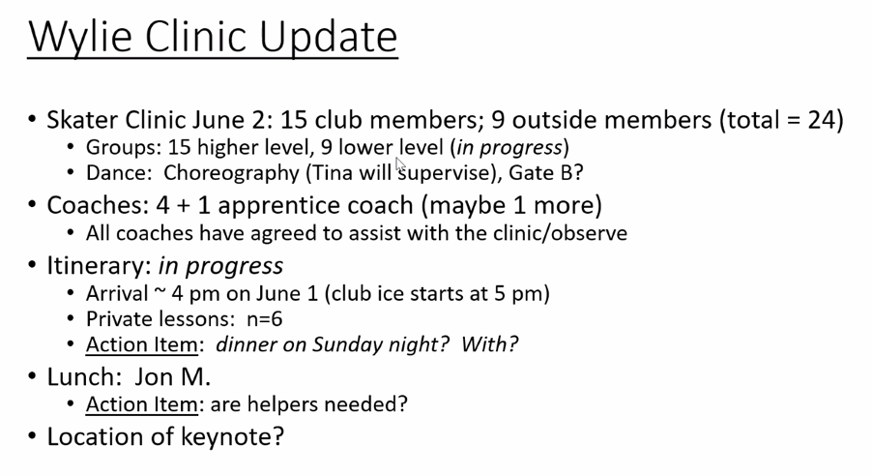
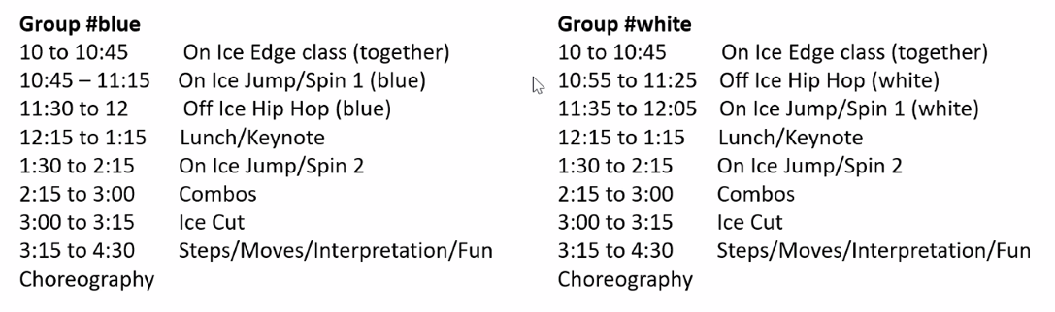
Budget: Estimated club cost $2381…actual approximately $1900

- Volunteer Proposal – Donna
  - Spreadsheet distributed via email
  - Determine volunteer hours by membership type
  - Established accounting system and responsibility (EntryEase has a volunteer time capability) Gloria offered to oversee tracking data.
  - Donna to refine model and options and distribute
  - Needs to be set before new membership year (7/1/24)

- Governing Council Update – Beth, John
  - Table until next meeting when Beth attends

- Web Site Update - John, Lori
  - Close to begin migration, there is a plan to be fully converted by August

- Social Media and minors – John, Lori
  - Nothing significant to report, pending actions: responding to Kendall's request and Juliana offered to help post

- Centre Gives Review – Tina
  - Raised $4000 (low by historical averages)
  - Expect ~$1000 more from stretch pool
  - 32 unique donors
  - Compiled notes—Centre Gives folder in shared drive
  - Owe thank you—photo Saturday

- Rachel Meeting Update – Tina/John
  - AY Competition Proposal
    - Pitched that Club could support hosting AY
    - Open to partnership
  - Education for both Aspire/Club Members on Judging, Club Intro, Testing
    - Will need volunteers to support education program events

- Testing – Jess/Tina/John
  - Test Costs review
    - $70 Free skate / MIF (11 min)
    - $40 Dance (typically done in threes for the same amount of time 3x 4 min)
      - Proposal: $40 for 1, $30 for second, $20 for third
    - Goal is to cover ice cost
    - Analyze annual data to assess demand and costs (John, Anne)

- New items not covered in this agenda
  - Need Club trifolds
  - Incorporate a start-of-season parents meeting

- Date of next meeting: June, TBD

- Adjourn 10:12PM: Lori, 2nd Jon, ALL APPROVED

