NVFSC Board Meeting Minutes
December 10, 2025; 8:00 PM

In attendance: Ann Birchard, Natalie Branstetter (departed at 8:20), Terry Branstetter, Aviva Cantor, Lori Coup, Beth Kalbach, John Kalbach, Donna Korzick, Gloria Leous (joined 8:36), Jon Malcos, Anne Martin, Jess McCormick, Gary Mitchell, Rui Zhu (joined 8:37)

- Call to order: 8:04PM

- Approval of minutes from November 19, 2025 meeting, Ann motion, Gary 2nd, ALL APPROVE

- Junior Board Update – Natalie
  - Past Saturday group meetup–Momotaro (made motivational notes for ice show, available on registration table)
  - Ongoing Spirit week–successfully with social medial/ice show posts
  - Ongoing food drive (~5 free tickets so far, expect more on Thur/Sun)
  - Gift exchange, after show for anyone who signed up–time and place in news letter
  - Fun skate/Ugly sweater in Jan

- Membership Report – Ann
  - USFS Fee Update: Membership processing fees. See about using eChecks to save fees.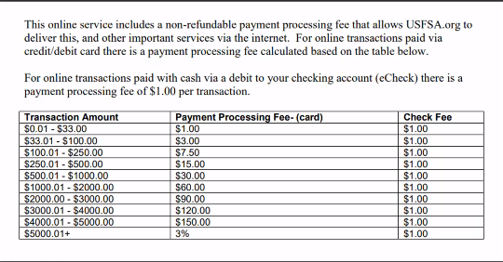
  - No Change to membership. Not yet received Aspire numbers.

- Testing – John/Jess
  - 2/27/26 8-9PM

- Fundraising – John/Gary
  - Nothing significant to report

- Apparel – Lori
  - Will share the number of jackets
  - Marlana, Whintey, Fang Wang to take over sales

- Web Site Update – John
  - Jr. Board–how to identify on website? Photos, description, don’t add specific names. Natalie to send to John
  - 90% complete, feel free to preview, nittanyvalleyfsc.org. Cutover date, TBD.

- Holiday Show – John
  - Concessions? Requested, awaiting response for Saturday and Sunday. Subway will be open.
  - General Updates
    - Four Seniors (all attending)
    - 6 Gold Medalists (five confirmed, hoping for sixth)
  - Sunday ice: 12:30 - 3:30 (can extend to 4PM if needed)
  - Wristbands/stamps for parents for back hall access (helping with skates)--Ann to provide holiday stamp to registration

- Club Ice – John/Anne/Jon
  - Beaver Stadium Session
    - Survey
      - 1st: Everyone Can Skate an hour $20 (Option 4)
      - 2nd: First 30 minutes only Full, $20, limited to 35. Second 30 Full and Jr (16 count), free. (Option 3)
    - Non-skating members? Yes, bring own skates
    - Option 3 with the option to split the first 30 minutes as needed.
  - Club Ice Spring
    - Summary Notes (linked)

- Spring/Summer Clinic– Aviva
  - Dates?: Ice and American Ice Theater availability
    - Trying to deconflict Excel and Penn/Jersey series events dates
    - Won’t be able to confirm ice before late Jan
  - Aviva to continue to work, including backup plan

- Treasurers Report – Rui
  - No major changes from prior report
  - Looking like a small (<$1000) loss on ice cost this fall (better than a year ago)
  - Clothing sales remain to be posted
  - Move to eCheck for membership processing

XIV. Date of next meeting: to be scheduled in early Jan

XVI. Adjournment 9:31PM, motion Ann, 2nd Jess, ALL APPROVE

