NVFSC Board Meeting Minutes
October 21, 2024; 8:00 PM

- Call to order: 8:02 PM

- Attendance: Terry Branstetter, Ann Birchard, Lori Coup, Beth Kalbach, John Kalbach, Donna Korzick, Gloria Leous, Jon Malcos, Anne Martin, Jess McCormick, Gary Mitchell, Rui Zhu, Natalie Branstetter, Aviva Cantor

- Approval of minutes from September 16, 2024 meeting – Motion Ann, 2nd Donna, ALL APPROVE

- Junior Board Update – Natalie
  - JB meeting – first Sunday Club of month (30 minutes prior to club activities, tentative)
  - Officer meeting 10/22 – getting organized
  - Halloween Skate – 10/29, item for JB officer to discuss (share by 10/23 for 10/24 Newsletter). Lori to support promotion.
  - Separate Shared Drive created for JB–access to officers and advisor

- SCASD Home Coming Parade October 17 review – Donna
  - Well planned and executed
  - 18 skaters, multiple coaches and chaperones
  - ~$93 spent on pizza (too much pizza), donated decorations

- Membership Report – Ann
  - 73 total
  - Working through discrepancies in EntryEze and reporting updates
  - Add Aspire to last year’s trends
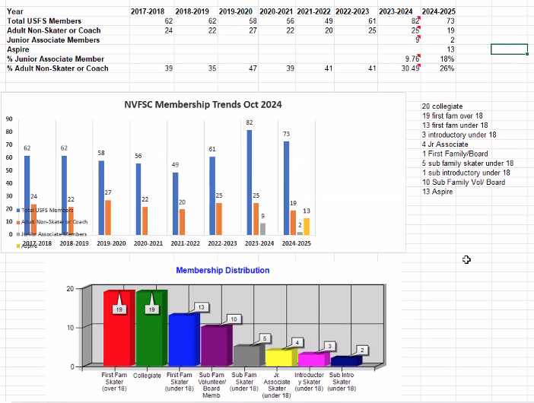

- Holiday Show Update – Donna/John
  - Sign-ups complete
    - Will lock app tonight
    - 70 responses (62 last year, without Aspire)
  - One Aspire Learn to Skate group number–need to confirm names and invoice
  - Game of Chance: are we having 50/50?
    - Do we get to keep the full 50%? If so, we will run.
    - John to ask Brian (Donna will take lead if approved)
  - Follow-up with Anderson Window Sponsorship (John will ask Tina)
  - Will ask to turn off Live Barn during Show and Practice
  - Food Drive–Giulia to coordinate (John to coordinate with Brian)
  - Advertising – Lori (lesson from last year in Shared Drive)
  - Updated Show Yard Signs
    - Get quote (Donna)
    - Motion Anne for new yard signs within $350 budget, 2nd Ann, ALL APPROVE
    - Lori to assist with design
  - Guidance for Ice Show Committee for program selection?
    - First step is to inventory the submissions–Jess
    - Club member priority
    - Confirm club membership
  - First practice–11/16/24

- Club Ice – John/Anne/Jon

- Testing – John/Jess
  - Good participation
  - USFS Virtual-Test Merchandise
  - Discussion on Test Session Length
    - We have asked for 90 minutes to allow for a 30-minute warm-up. We’ve not been using more than 60 (and giving the extra time back). Do not expect to have Freestyles scheduled prior to test sessions.
    - OPTION – We could open the warm-up to club. (Not included in subscription.) “Our own Freestyle”
    - OPTION – Club membership could include testing ice time on club ice. Could lower tester cost.
    - OPTION – Could find (FS and/or Club) sessions that are lightly attended and suitable for testing.
    - OPTION – Could add private program practice time to testing sessions to help defer Club cost.

- Used Skate Sale
  - Logistics information to be in this week’s Newsletter
  - Lori supporting graphics

- Volunteer Update – John/Donna/Anne
  - Add field to sign-up to capture which skater is being supported
  - Future Newsletter piece on process and checking status

- Fundraising – Gary
  - Concession Stands – Distributing RAMP training
  - Games this weekend with good RAMP coverage
  - Gates open 1.5 hours before start
  - Items for sale are changing

- Governing Council Update – Beth, John (tabled)

- Web Site Update - John, Lori (tabled)

- Treasurers Report – Rui (tabled)
  - Question on Reimbursement Process during transition

- Date of next meeting – 11/18/24 8PM

- Adjournment 9:31PM – Motion Ann, 2nd Donna, ALL APPROVED

